TABLE OF CONTENTS

INTRODUCTION:-
Echolocation is a specialized type of acoustic communication in which an animal sends information to itself. About 20% of all mammalian species (mostly bats) have overcome the problem of orienting themselves and locating objects in darkness or where vision is otherwise limited by producing short-duration sounds and listening for reflected echoes as the sounds bounce off objects in the environment.
Echolocation is used by several animals such as bats, dolphins, toothed whales and some nocturnal birds. Animals use it for hunting, communicating, detecting predators and avoiding obstacles in dark or turbid waters.
Echolocation has evolved independently in at least five mammalian lineages. Microchiropteran bats are well-known echolocators and so too are some shrews, golden hamsters, flying lemurs, and some marine mammals, notably odontocete cetaceans.
Small dolphins have been the principal subjects of most captive echolocation studies, although other
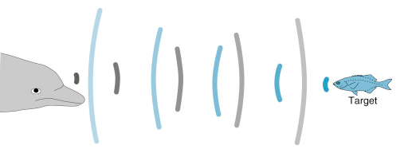
The above figure shows how the clicks produced by the dolphin bounces off objects. The distance between the dolphin and the target is calculated by determining the amount of time it takes for the reflected echo to reach it.

HISTORY AND DISCOVERY:-
By 1938, the echolocating abilities of bats were clearly demonstrated (Pierce and Griffin, 1938); yet another 25 years passed before echolocation in dolphins was reported. Kellogg et al. (1953) reported that captive dolphins could hear sounds up to 80 kHz, and McBride (1956) presented some of the first evidence that bottlenose dolphins could use echolocation to detect underwater objects. For a more detailed account of the early dolphin echolocation studies, see Au (1993). Recent research has shown strong support for convergence among bats and the bottlenose dolphin in numerous genes linked to hearing related to echolocation (Parker et al. 2013).
Since the first reports of the echolocating abilities of odontocetes (especially captive dolphins), research interest has been intense. Because echolocation can only be confirmed for captive animals that are deprived of access to their other senses, fewer than a dozen species of small odontocetes (mostly delphinids) are the only marine mammals unequivocally known to echolocate. However, it is reasonable to assume that all odontocetes actively use echolocation given that all of the toothed whales produce click- or pulse-like sounds in the wild.

ECHOLOCATION IN LAND VS MARINE ANIMALS:-
Sound travels 344 metres per second (m/s) in air, as opposed to 1,482 m/s in water. Sound therefore travels 5 times faster in water than in air. Moreover, whales and bats, for example, do not seem to emit the same frequencies. Whales hear sounds with frequencies ranging from 10 Hz (infrasonic) to 60,000 Hz (ultrasonic). The frequency range perceptible to bats is higher, i.e. from 20 to 150,000 Hz.
The giants of the seas are therefore masters of emitting low frequencies, while bats specialize in high frequencies. Many insects can detect and respond to the sounds of bats, while most fish and squid do not react to whale signals, though they are able to detect water movements generated by their approaching predators. These differences have an impact on how whales and bats use echolocation.
Consider the example of whales and bats to demonstrate the differences in echolocation between land and marine animals.
Toothed whales echolocate using their melon, the large bulge on their forehead. To do so, they emit sound waves into the water that bounce off various objects and organisms. When the sound strikes an object, it returns to the animal through sound-conducting tissue in the lower jaw. From there, it continues onward to the inner ear. This ability enables the animals to detect objects or prey in their dimly lit environments.
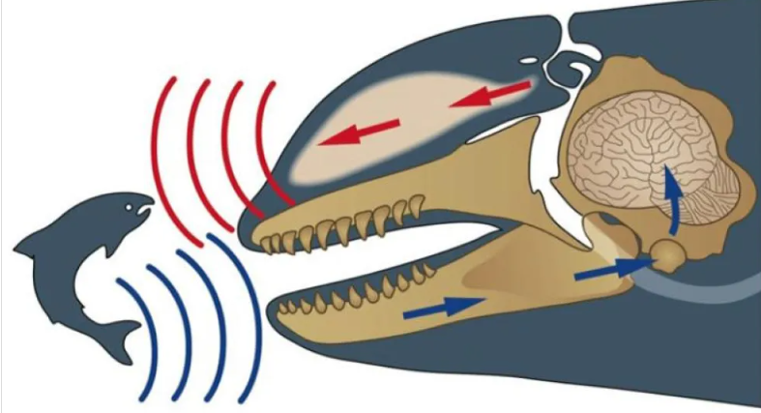

As for bats, these mammals produce sounds of up to 140 dB with their larynx, which are then emitted from their mouths. These ultrasounds and can reach up to 150,000 Hz, which is well beyond what humans can hear. The high frequencies they emit have short wavelengths and are therefore well reflected by small targets such as insects. Indeed, bats can detect insects up to 5 metres away and even avoid objects as fine as a human hair. To avoid being stunned by their own calls, they close their middle ear just before they emit the sound, restoring their hearing a fraction of a second later in order to listen for echoes.
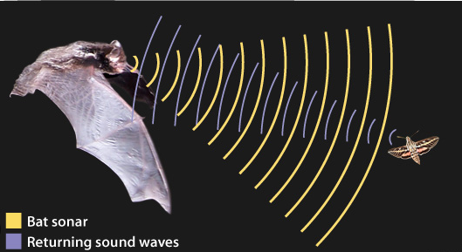

Although toothed whales and bats are some of the best known animals when it comes to echolocation, there are many others that also have this uncanny ability, Oilbirds, for example, are nocturnal birds that use high-pitched (though audible to humans) clicking to navigate in the dark. Additionally, some shrews are believed to use ultrasonic squeaks to explore their environment. Tenrecs, small insectivores native to Madagascar, are reported to click their tongues when foraging for food. Lastly, it’s possible that hedgehogs might use a hissing-like ultrasound, though it has not yet been definitively proven that they have this capacity.

ECHOLOCATION VS VISION:-
Most species of bat navigate in darkness by emitting ultrasonic pulses and listening to the returning echoes that reflect from objects in the environment. In this way, bats build an acoustic image of their surroundings, but, contrary to popular belief, bats are not blind. Some bat species have a keen sense of sight that would allow them to navigate in daytime without the aid of echolocation. In particular, Egyptian fruit bats (Rousettus aegyptiacus) are cave dwellers that have prominent eyes which allow them to see even in low light conditions¹. Additionally, these bats are lingual echolocators, that is, they use tongue clicks as a form of echolocation to aid their navigation
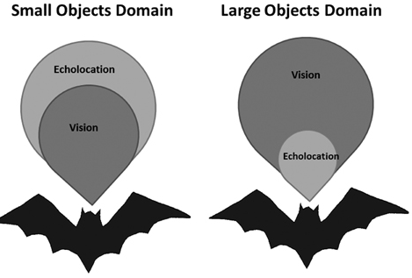
- we compare the echolocation and visual detection ranges of two such species of bats which rely on different foraging strategies (Rhinopoma microphyllum and Pipistrellus kuhlii)
- We find that echolocation is better than vision for detecting small insects even in intermediate light, while vision is advantageous for monitoring far-away landscape elements in both species. We thus hypothesize that, bats constantly integrate information acquired by the two sensory modalities.
- We suggest that during evolution, echolocation was refined to detect increasingly small targets in conjunction with using vision. To do so, the ability to hear ultrasonic sound is a prerequisite which was readily available in small mammals, but absent in many other animal groups.

Echolocation is surely advantageous over vision in extremely dark or lightless environments such as caves, but many bats customarily emerge from their roosts immediately after sunset at intermediate light levels (1–10 lux) when insect abundance peaks
vision is advantageous for the detection of large objects (e.g., cliffs, trees, etc.) and echolocation is advantageous for detecting small objects such as insects even when there still is some light. We therefore suggest that echolocation is advantageous over vision even in intermediate light levels when hunting for small prey. This finding implies a force that might have pushed the evolution of echolocation

TECHNOLOGICAL APPLICATIONS OF ECHOLOCATION:-
Echolocation isn’t only restricted to dolphins. People accommodated this rule into sonar, that sends pings inside the water & listens for the echoes. The achievement of sonar later developed into radar, which happens to be the same concept, but having radio waves into the air.
1.RADAR:-
The word radar comes from the acronym Radio Detection And Ranging.
Consider the WSR-88D is a pulsed Doppler radar. This means that the transmitter sends out very brief pulses of radio waves rather than a continuous stream of waves.
By calculating the amount of time it takes for a pulse to be transmitted, strike a target, and return to the radar antenna, the system can determine the range (or distance) of the target from the radar.
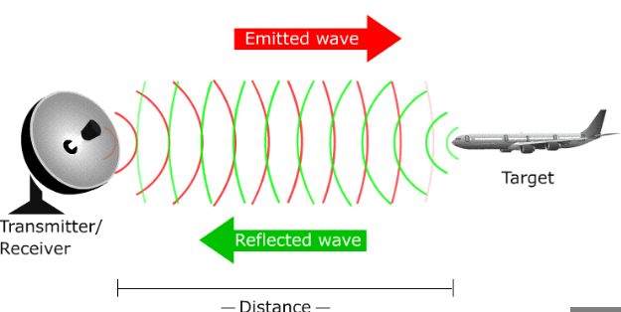

2.SONAR:-
Sonar, short for Sound Navigation and Ranging, is helpful for exploring and mapping the ocean
scientists primarily use sonar to develop nautical charts, locate underwater hazards to navigation, search for and map objects on the seafloor such as shipwrecks, and map the seafloor itself. There are two types of sonar—active and passive.
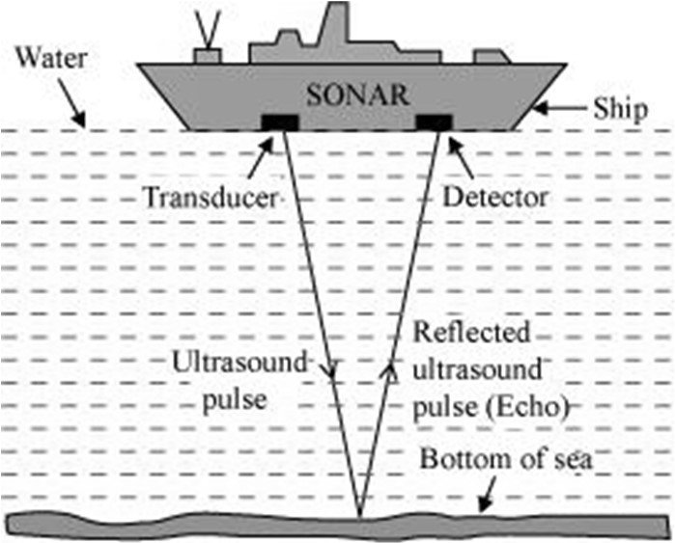

Active Sonar
Active sonar transducers emit an acoustic signal or pulse of sound into the water. If an object is in the path of the sound pulse, the sound bounces off the object and returns an “echo” to the sonar transducer. If the transducer is equipped with the ability to receive signals, it measures the strength of the signal. By determining the time between the emission of the sound pulse and its reception, the transducer can determine the range and orientation of the object.

Passive Sonar
Passive sonar systems are used primarily to detect noise from marine objects (such as submarines or ships) and marine animals like whales. Unlike active sonar, passive sonar does not emit its own signal, which is an advantage for military vessels that do not want to be found or for scientific missions that concentrate on quietly “listening” to the ocean

3.LIDAR:-
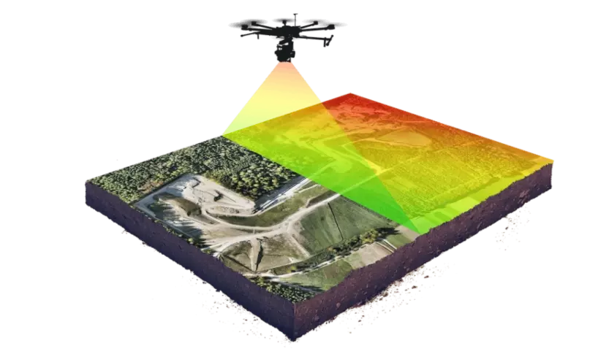

Lidar is a complex remote sensing technology using laser light to densely sample the surface of an object. Currently, it is being used by archeologists to delve into the hidden layers of the earth..
Lidar systems lasers use pulses of light outside the visible spectrum and measure how long it takes each light pulse to come back. As it does, the distance to and direction of whatever that pulse hit is documented as a single point on a large 3D map, with the lidar system at the middle.
In recent years, archaeologists have started using Lidar to map the height of features on the ground. One of the largest, most recent surveys helped archeologists determine that the Mayan civilization may have been much larger and more tightly populated than thought before.
Lidar helped the scientists cover 2,000 kilometers in a relatively short period of time. Covering that much land by hand, using ground penetrating radar, would have taken decades. But Lidar’s usefulness doesn’t stop there.
There are also multiple types of Lidar, including flash lidar and phase array lidar.
Flash is basically where you have a light source and that light source floods the entire field of view one time using a pulse. A time-of-flight imager receives that light and is able to paint the image of what it sees
The downfall of flash lidar is the expense. It requires huge bursts of energy and expensive imagers made from gallium-arsenide to capture the light. These imagers can cost upwards of $200,000.
Fortunately, a close cousin of lidar known as the phased array, is a brilliant workaround. It can broadcast radio waves in any direction using a microscopic array of individual antennas synced together. By monitoring the timing — or phase — between each antenna broadcasting its signal, engineers can “steer” one signal in a specific direction. This is the first step in using lidar for autonomous vehicles.
Also, Lidar can’t do it alone: it can’t read signs since they’re flat; the systems can be disrupted easily by limited visibility (heavy snow, fog, or something else obstructing the unit’s view).
So, to work in a vehicle, lidar has to work together with other systems: its cousins’ radar and ultrasound (a form of sonar) and ordinary visible-light cameras help Lidar. The cameras may read a “bump” sign on its own, but cameras are slow to process information and might not realize the sign is there until it’s too late.

4.Devices For The Blind People
Those who could profit most from modern sound tech are the blind. Most of the blind people utilize sound like a director, many of them exercising long & hard enough to obtain a kind of echolocation. This knowledge has been adopted to develop devices to assist the blind pilot the world properly.
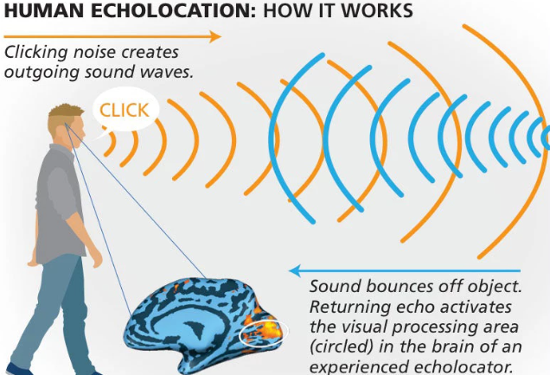

5.Ultrasound:-
Ultrasound is sound waves with frequencies higher than the upper audible limit of human hearing
Medical ultrasound (also called sonography or ultrasonography) is a diagnostic imaging technique based on the application of ultrasound. It is used to create an image of internal body structures such as tendons, muscles, joints, blood vessels, and internal organs.
Compared to other dominant methods of medical imaging, ultrasound has several advantages.
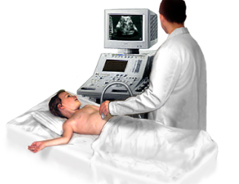
- It provides images in real-time and is portable and can be brought to the bedside.
- It is substantially lower in cost than other imaging modalities and does not use harmful ionizing radiation.
Drawbacks include:
various limits on its field of view, such as the need for patient cooperation, dependence on physique, difficulty imaging structures behind bone and air, and the necessity of a skilled operator, usually a trained professional.

Challenges and Limitations in Biology
Biology, the study of living organisms and their interactions with each other and their environments, faces numerous challenges and limitations. These can be broadly categorized into technical, ethical, environmental, and conceptual challenges.

Technical Challenges
- Complexity of Biological Systems:
  - High Complexity: Living organisms are incredibly complex, with numerous interacting systems at molecular, cellular, organismal, and ecological levels.
  - Data Overload: Modern techniques like genomics, proteomics, and metabolomics generate vast amounts of data that can be difficult to analyze and interpret.
- Technological Limitations:
  - Microscopy: Despite advances, limitations in resolution and imaging depth can hinder our understanding of cellular structures and dynamics.
  - Sequencing Technologies: Although sequencing costs have dropped, challenges remain in accurately sequencing and assembling large, repetitive genomes.
- Experimental Constraints:
  - Model Organisms: Findings from model organisms (e.g., mice, fruit flies) may not always translate to humans or other species.
  - In Vitro vs. In Vivo: Experiments conducted in vitro (outside a living organism) might not accurately reflect in vivo (within a living organism) conditions.

Ethical Challenges
- Human and Animal Research:
  - Ethical Standards: Balancing the need for scientific advancement with the ethical treatment of human subjects and animals can be challenging.
  - Informed Consent: Ensuring that human participants fully understand the implications of their involvement in research.
- Genetic Engineering and Biotechnology:
  - CRISPR and Gene Editing: Ethical concerns about the potential for misuse, unintended consequences, and genetic inequality.
  - GMOs: Public skepticism and regulatory hurdles regarding genetically modified organisms in agriculture and medicine.

Environmental Challenges
- Biodiversity Loss:
  - Habitat Destruction: Rapid loss of habitats due to human activities threatens many species with extinction, complicating conservation efforts.
  - Climate Change: Changing climates impact species distributions, behaviors, and interactions, posing a significant challenge for biologists studying ecosystems.
- Pollution:
  - Chemical Pollutants: Pollutants can disrupt biological processes and ecosystems, making it difficult to study natural biological states.
  - Microplastics: Emerging contaminants like microplastics present new challenges for understanding their long-term biological impacts.

Conceptual Challenges
- Understanding Complexity:
  - Systems Biology: Integrating data from multiple levels (genes, proteins, cells, organisms) to understand complex biological systems.
  - Emergent Properties: Studying how new properties and behaviors emerge from complex interactions within biological systems.
- Evolutionary Biology:
  - Speciation: Understanding the processes and mechanisms leading to the formation of new species.
  - Adaptation: Investigating how organisms adapt to rapidly changing environments in real-time.
- Interdisciplinary Integration:
  - Cross-Disciplinary Research: Combining insights from biology with physics, chemistry, mathematics, and computer science to tackle complex biological questions.
  - Translational Research: Bridging the gap between basic biological research and practical applications in medicine, agriculture, and industry.

Practical Limitations
- Funding and Resources:
  - Research Funding: Limited funding can restrict the scope and scale of biological research.
  - Resource Allocation: Unequal distribution of resources can lead to gaps in knowledge, particularly in under-studied areas or regions.
- Public Perception and Policy:
  - Science Communication: Effectively communicating scientific findings to the public and policymakers to foster understanding and support for biological research.
  - Regulatory Challenges: Navigating complex regulations and policies that govern biological research and its applications.
In summary, the field of biology faces a myriad of challenges and limitations that stem from the inherent complexity of living systems, technological and ethical constraints, environmental changes, and practical considerations. Overcoming these challenges requires interdisciplinary approaches, technological innovation, and a careful balance of ethical considerations.

IMPACT OF HUMAN ACTIVITIES ON ECHOLOCATING ANIMALS
Human activities have significant impacts on echolocating animals, affecting their ability to navigate, find food, and communicate. Here are some key ways in which human activity influences echolocating species:

Noise Pollution
- Marine Environments:
  - Ship Traffic: Increased shipping traffic creates underwater noise that interferes with the echolocation of marine mammals like dolphins and whales.
  - Sonar Use: Military and commercial sonar can disrupt the echolocation and communication of these animals, sometimes leading to strandings.
- Terrestrial Environments:
  - Urban Noise: Traffic, construction, and industrial activities generate noise that can interfere with the echolocation of bats, making it difficult for them to hunt and navigate.
  - Wind Turbines: The noise from wind turbines can disrupt bat echolocation and lead to collisions.

Habitat Destruction
- Deforestation:
  - Loss of Roosting Sites: Deforestation destroys roosting sites for bats, forcing them to find new habitats which may not be as suitable.
  - Reduced Prey Availability: Habitat destruction reduces the availability of insects and other prey for echolocating animals.
- Urbanization:
  - Habitat Fragmentation: Urban development fragments habitats, creating barriers that echolocating animals must navigate around.
  - Light Pollution: Artificial lighting can disorient bats and other nocturnal animals, affecting their ability to use echolocation effectively.

Pollution
- Chemical Pollution:
  - Pesticides: Use of pesticides reduces insect populations, limiting the food supply for insectivorous bats.
  - Water Contamination: Pollution of water bodies can affect the prey species of echolocating marine mammals and disrupt their ecosystems.
- Plastic Pollution:
  - Ingestion Risks: Marine animals may mistake plastic debris for prey, leading to ingestion and potential injury or death.
  - Entanglement: Animals can become entangled in plastic waste, affecting their ability to echolocate and move freely.

Climate Change
- Temperature Changes:
  - Range Shifts: Changes in temperature can cause shifts in the range of echolocating animals, forcing them to adapt to new environments.
  - Prey Distribution: Altered temperatures affect the distribution and abundance of prey species.
- Extreme Weather Events:
  - Habitat Damage: Hurricanes, floods, and other extreme weather events can destroy habitats and roosting sites for bats.
  - Behavioral Changes: Changes in weather patterns can affect the behavior and migration patterns of echolocating animals.

Overfishing
- Food Scarcity:
  - Reduced Prey Availability: Overfishing depletes the populations of fish and squid that marine mammals rely on for food.
  - Competition: Increased competition for dwindling resources can stress echolocating animals.

Conservation Efforts
- Protected Areas:
  - Marine Sanctuaries: Establishing protected marine areas helps reduce noise pollution and overfishing impacts on marine mammals.
  - Bat Conservation: Creating and preserving natural habitats and roosting sites for bats helps mitigate the impact of habitat destruction.
- Legislation:
  - Noise Regulations: Implementing regulations to limit underwater noise pollution from ships and sonar.
  - Pesticide Control: Reducing the use of harmful pesticides to protect insect populations.
- Public Awareness and Education:
  - Community Engagement: Educating communities about the importance of echolocating animals and promoting conservation efforts.
  - Reducing Light Pollution: Encouraging practices to reduce artificial lighting impacts on nocturnal wildlife.
In summary, human activities have a profound impact on echolocating animals, disrupting their ability to echolocate and survive. Addressing these challenges requires concerted conservation efforts, regulatory measures, and public awareness to protect these vital species and their habitats.

BIBLIOGRAPHY:-
https://www.frontiersin.org
https://www.iqsdirectory.com
https://oceanservice.noaa.gov
https://www.noaa.gov
https://www.flyability.com
https://www.sciencedirect.com
https://ocean.si.edu
https://baleinesendirect.org

